Step 1: Formatting text
- Font: Times New Roman
- Size:
Article text: size 10
Headline (title): size 14, bold, italics.
- Margins:
- Click on the “page layout” tab
- Click on margins
- Click on narrow
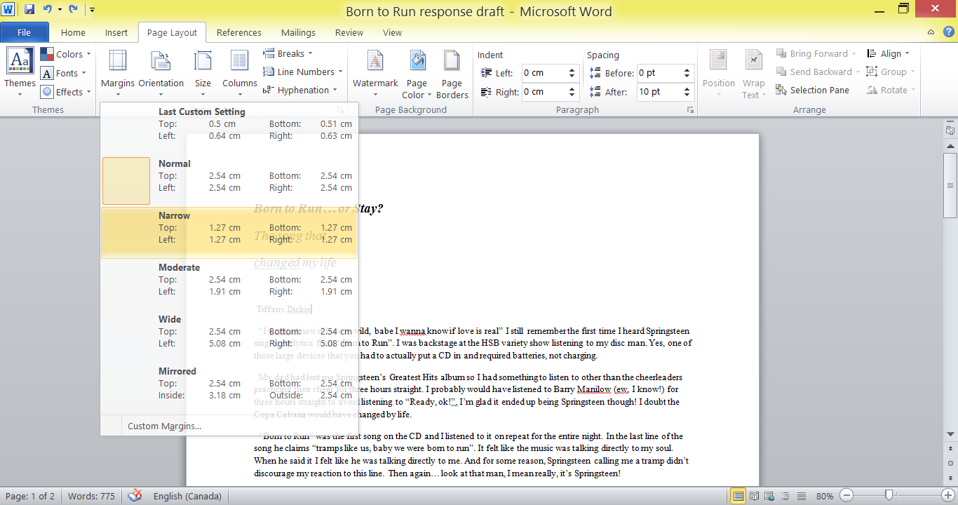
- Remove spacing between paragraphs
- Highlight article text
- Click on “Home” tab
- Click on “Line and paragraph spacing”
- Click on “Remove spacing after paragraph”
- 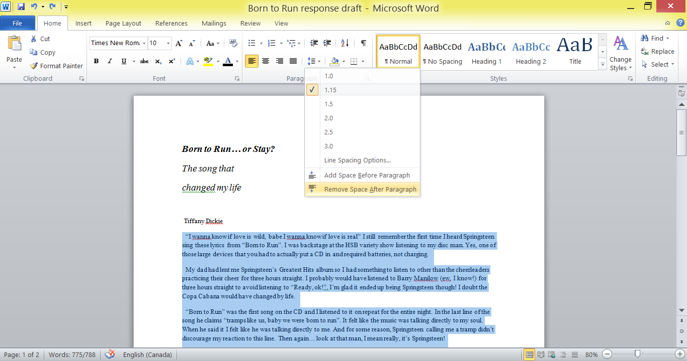

- Columns: 3 columns
- Highlight article
- Click on the “Page Layout” tab
- Click on “columns”
- Click 3 columns
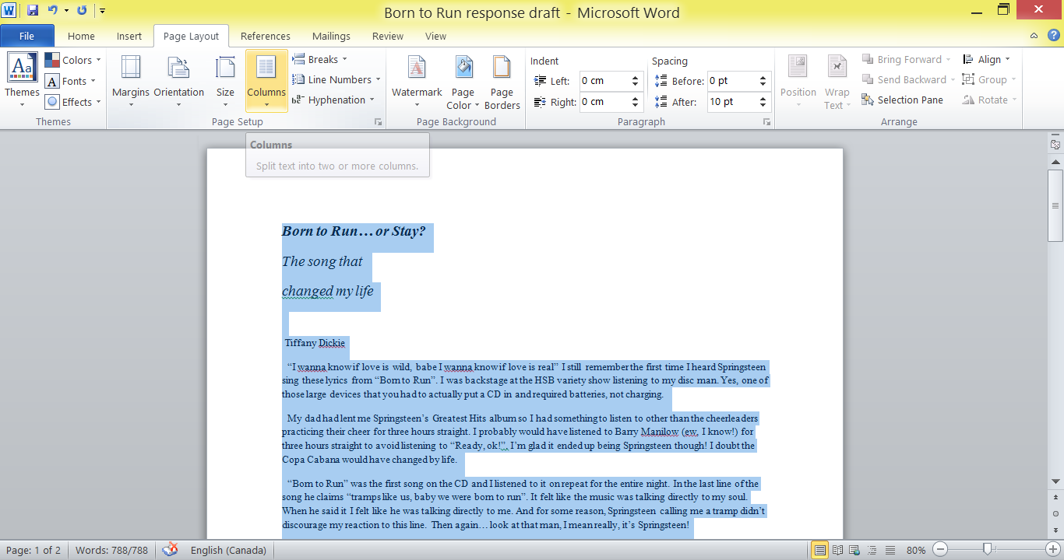
- Justify:
- Highlight article text
- Click on home tab
- Click “justify” in the paragraph section
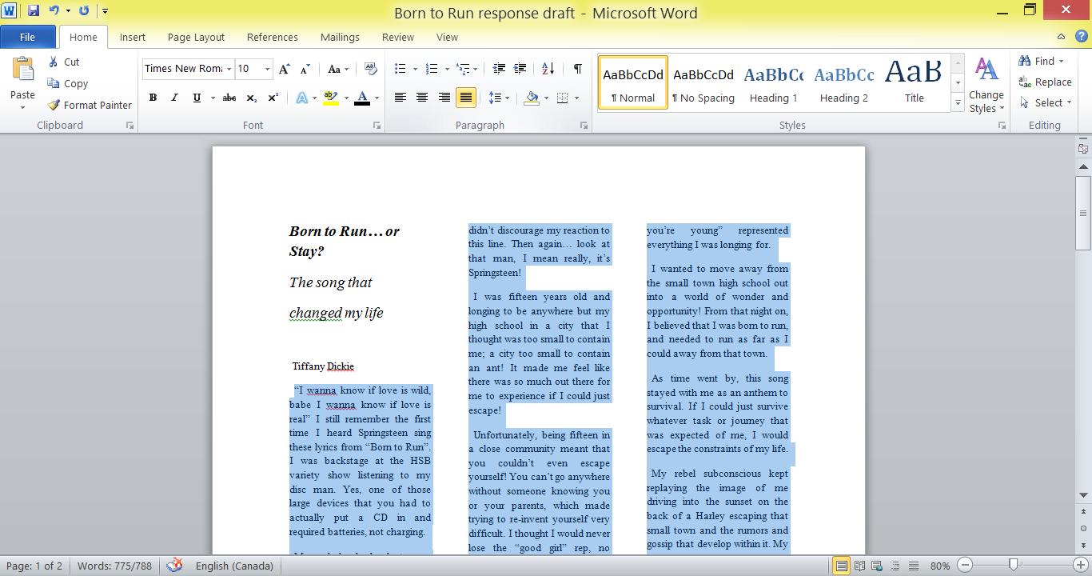

Step 2: Pictures
- Photo
- Copy and paste your picture into your document (or insert photo)
- Right click on the photo
- Go to “wrap text”
- Click on “Tight”
- Place your photo where you want it in your document – your text will wrap around it
- 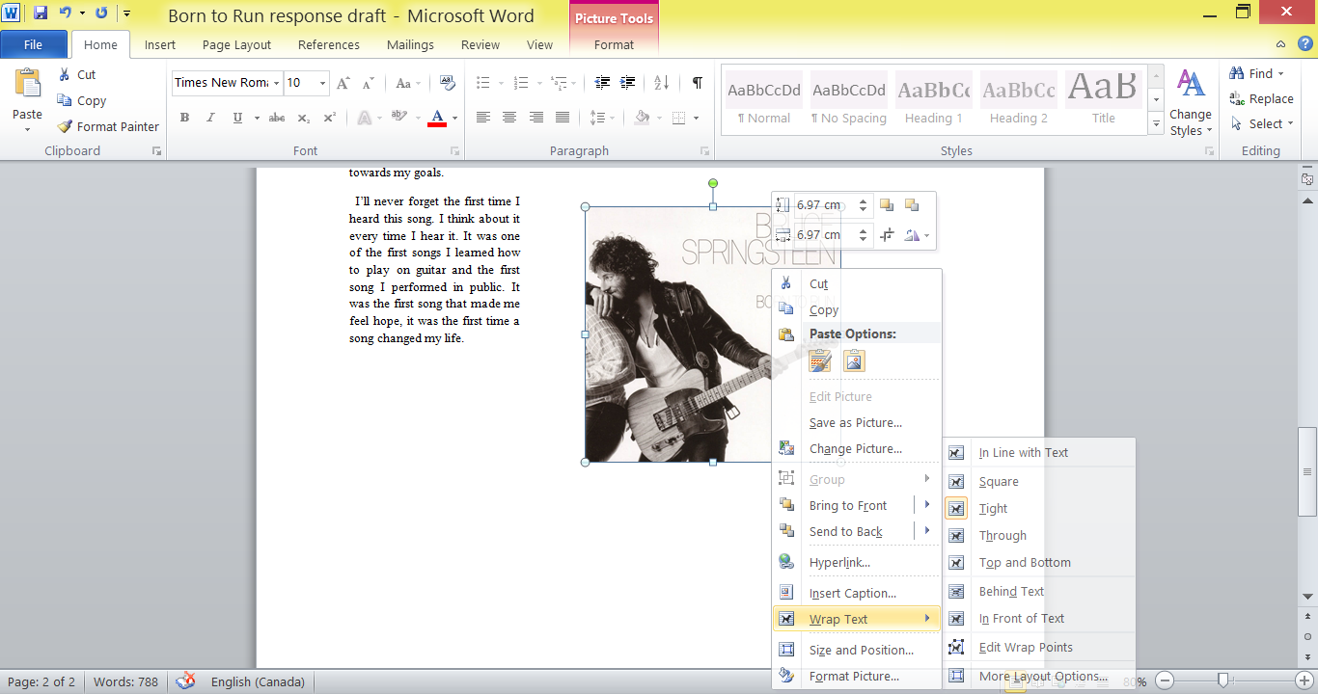
- Byline photo
- Insert your photo from your file.
- Right click on photo
- Go to “Wrap Text”
- Click on “In line with text”
- Place photo between subheading and byline (name)
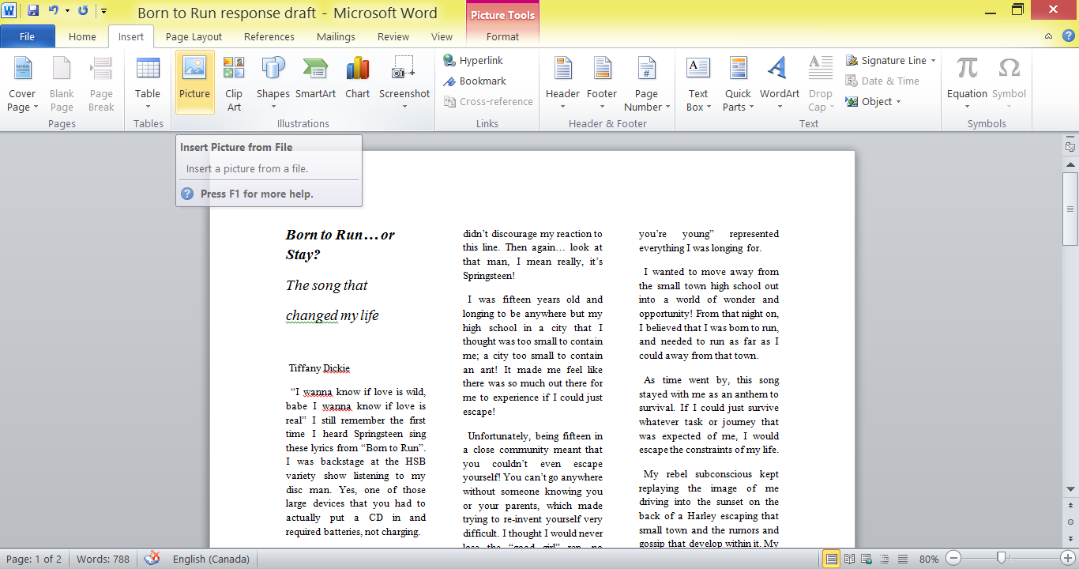

Cropping photo: If your picture has more than one person, or is more than just your face you need to crop it so that it is just your face.
- Click on photo
- Click on the tab “Picture tools – Format”
- On the right hand side, click on “Crop”
- Crop your photo by bringing the black corners to surround your face.
- Click away from the picture and only the portion that you selected will remain.
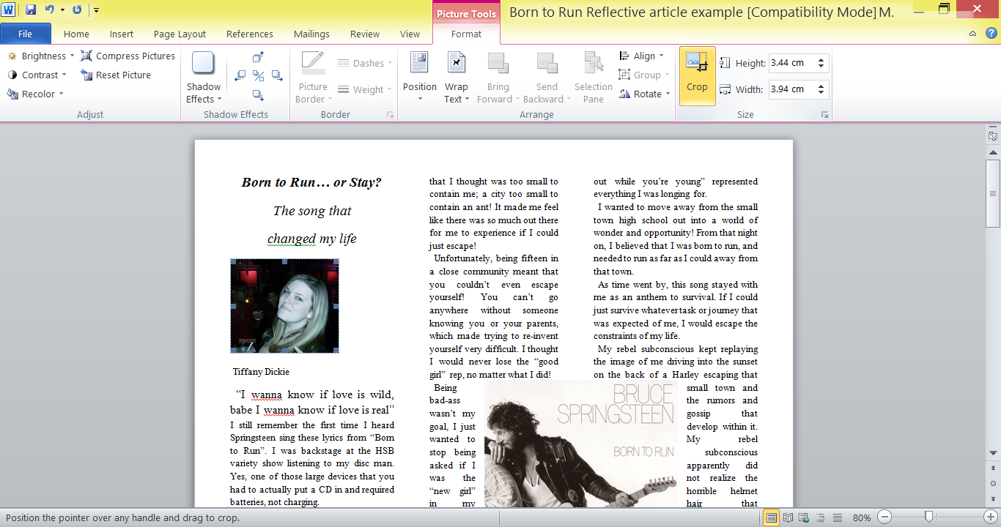
Step 3: Call-out: A call out is an eye-catching statement from your article that will draw your reader in. It can be either an alarming statistic, a powerful quote from your interview, or a part of your writing that you think will hook the reader.
- Click on the “Insert” tab
- Click on “text box”
- From the drop down options that you have, select “simple text box”

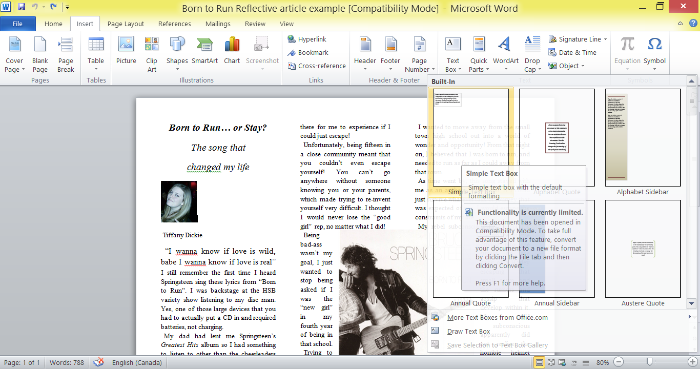
- Find a quote from your article (your writing, not lyrics from the song) and copy it into the text box
- Make the font size 14 so it will stand out on the page.
- Click on the text box
- Click on the “text box tools – format” tab
- Click on “Wrap text” (on the right”
- Click on “tight”
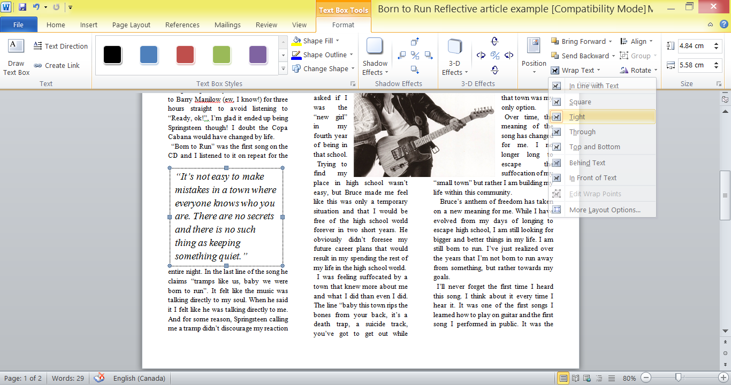
- Place the call-out in your article between the columns to make it stand out
Step 4: Finishing
- Adjust the size of the picture and call-out to your article fits nicely on one page.

