“Lightning Lou” by Lori Weber
Exploring the resilience and determination it takes to achieve your dreams.

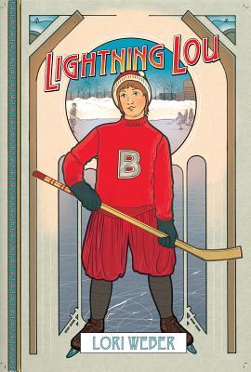

Reading Schedule:
Book Distribution: April 24th
Chapter 1-9: May 1st
Chapter 10-19: May 8th
Chapters 20-29: May 15th
Finish novel: May 23rd
- Historical Context – Due May 15th
Complete the tasks in the Canada in the War package exploring the cultural and historical importance of Canada in WW1 so you can identify and question the references (or allusions) while reading the novel. The tasks should be completed and submitted in a word document.
- Research project & Presentation: (3-5 minutes) - Presentations May 4th
In groups of 5, teams will prepare and present on one of the following topics:
- The role of women in Canada during WW1
- Conscription in Canada (with special focus on Quebec)
- Canada’s role in WW1
- Albertine Lapensée
Your presentation should include:

Research Topics
No matter what topic you choose, you will need to look into these areas as you conduct your research:
    - Historical roots/background of topic
    - Important people, ideas, and terms involved in the event/issue
    - How was the issue resolved?
    - If your topic is an issue, include your opinion of the issue and a proposal of how the issue could be dealt with based on your research.
    - If your topic is not an issue, look for information that explains why it was a significant/important event in history.

Research Requirements
~You must include a minimum of five sources from the online databases

Presentation
You will present your research to the class using PowerPoint. The PowerPoint presentation should be an outline of your main points that you explain and expand on as you present to the class.
Scoring Rubric for Oral Presentations:
Category | Scoring Criteria | Total Points | Score
Organization  (15 points) | The type of presentation is appropriate for the topic and  audience. | 5
 | Information is presented in a logical sequence. | 5
 | Presentation appropriately cites requisite number of references. | 5
Content  (45 points) | Introduction is attention-getting, lays out the problem well, and establishes a framework for the rest of the presentation. | 5
 | Technical terms are well-defined in language appropriate for the target audience. | 5
 | Presentation contains accurate information. | 10
 | Material included is relevant to the overall message/purpose. | 10
 | Appropriate amount of material is prepared, and points made reflect well their relative importance. | 10
 | There is an obvious conclusion summarizing the presentation. | 5
Presentation  (40 points) | Speaker maintains good eye contact with the audience and is appropriately animated (e.g., gestures, moving around, etc.). | 5
 | Speaker uses a clear, audible voice. | 5
 | Delivery is poised, controlled, and smooth. | 5
 | Good language skills and pronunciation are used. | 5
 | Visual aids are well prepared, informative, effective, and not distracting. | 5
 | Length of presentation is within the assigned time limits. | 5
 | Information was well communicated. | 10
Score | Total Points | 100

- Guided reading: Check-Ins May 15th, Final Submission May 24th
Throughout the reading of the novel you will be recording journal assignments in your readers/writers notebooks. Remember that these are not a summarizing task but rather an analysis task. Some things to consider are:
- Sign posts (looking for them and considering their significance)
- Questioning character actions or statements
- Looking at the historical significance of the novel.
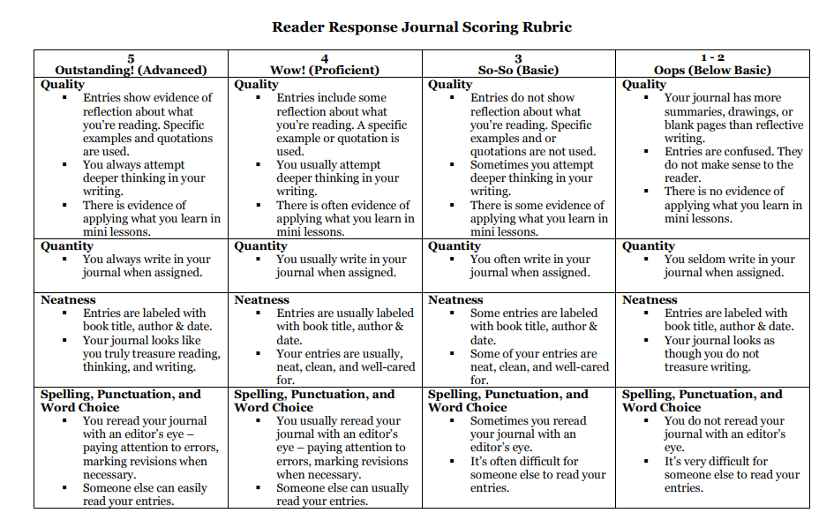
You should have at least one entry per chapter because each chapter has a purpose in the novel and it is your job to consider that purpose.

- Sign Post Snap Chat: Check-Ins May 15th, Final Submission May 24th
Throughout the novel you must find 6 examples of signposts in the novel. You may repeat one signpost more than once, but you must have at least 3 different ones. You will require the following in each snap:
- A photo of the page with the text highlighted, underlined, or circled.
- The name of the signpost you are identifying.
- An analysis of the significance of this post (a few lines).
You will submit the pictures through my website. You should also keep the in a folder on your computer so you have everything together.
Sign Post Snap Chat Rubric
 | Advanced (5) | Proficient (4) | Basic (3) | Below Basic (2)
Content/  Responses  This is double weighted | Exhibits a level of comprehension that extends beyond the literal to the personal, critical and evaluative | Exhibits a level of comprehension that extends beyond the literal to the personal with some critical response. | Exhibits a level of comprehension that is mostly literal or personal with few critical responses. | Exhibits a level of comprehension that is mostly literal with some personal responses and no critical responses.
Relevance of content from text | All content is through, thoughtful and relates relevant ideas of text | Most content is fairly thorough, thoughtful and relates most of the relevant ideas of the text. | Some content is thoughtful, but most is incomplete or irrelevant. | Most content is disjointed, incomplete or irrelevant.
Conventions | Few errors (if any); neat and clear; easy to follow. | Errors are present, but do not interfere with meaning; mostly organized and neat | Errors present that interfere with meaning; little organization; messy | Errors prohibit understanding; sloppy; disorganized

- Self-Discovery Reflection (300-400 words) – Due May 1st, 8th, or 15th
Throughout this year we have been looking at resilience and overcoming adversity. You are about to enter senior school. Consider what you have learned about yourself during your time in middle school. What have you fought for? Who have you befriended, or unfriended? How have your experiences shaped the student you are today and how to you think that person will do in senior school?
You will be assessed using reflective writing/ narrative rubric.
- Sports Narrative (200-250 words) - Due May 1st, 8th, or 15th
Capturing sports action is challenging. It’s hard not to be repetitive. How many ways can you describe someone dribbling a ball, or skating?
- Choose a sport that is interesting to you.
- Watch some video clips of the sport paying particular attention to the terms the announcer is using.
- Create a word cloud of verbs associated with the sport you chose.
- Write a scene from a game, match, or event of that sport without using the same verb twice. (see example below)
When Coach tapped his shoulder to send him back out, his legs jumped into action and he took off toward Lapensée, who had the puck and was heading down for another shot. Danielle stood in her way, ready to stop her. But before Lapensée reached the defense, Lou zoomed in front of her and scooped the puck away. He was half way back up the ice now, his eyes glued to the Cornwall net. Every second another foul word, the kind that would have Maman reaching for the soap, hit his ears. He used them to push himself forward. He heard Claire to his right, urging him to pass her the puck. Should he trust her? The Vics’ defense were closing in on him, so he did. Claire kept up with him, and just when a defenseman was about to hit her, she passed the puck back to Lou. It wasn’t the most precise pass, sailing a foot past his stick, but he lunged forward and picked it up. Within seconds, two girls bumped him, one on either side, sandwiching him between them. But they couldn’t stop him. He sent the puck ahead and jumped over them to retrieve it. He could feel Lapensée behind him, breathing dragon fire down his neck. He wound up and smashed the puck with all his force.
You will be assessed using reflective writing/ narrative rubric.

- Historical Narrative (300-400 words) - Due May 1st, 8th, or 15th
Weber conducted in depth research of the historical context of the novel prior to writing it. It is that context that creates the realistic imagery and historical allusions within the text.
- Choose a country and a time period that interests you. It could be anywhere at anytime. For example, life in ancient Egypt during the building of the Great Pyramids, or England during the reign of Bloody Mary.
- Do some historical research, gathering 5 or 6 facts about the daily life of the people. (be sure to submit the research)
- Write a scene from the point of view of someone your own age, describing your surroundings and including action and dialogue. Try to capture the flavour of the time. What are you wearing? Eating? Playing? Do you study or work? How many siblings do you have? What does your house look like? Are you free? Enslaved? Very rich or very poor? Are you married? Do you have dreams?
You will be assessed using reflective writing/ narrative rubric.

Reflective Writing/ Narrative Rubric
 | Advanced—4 | Proficient—3 | Needs Improvement—2 | Not Yet—1
Content

Lead | Strong lead makes the reader want to find out more | Good lead but could be altered though the reader still wants to continue | Lead is unremarkable and needs some work | Lead is unimaginative or too obvious and needs to be rewritten
Idea Development | Length of paper is appropriate and flows smoothly from one idea to the next | A few instances of clutter and/or not enough elaboration, but for the most part flows evenly | Good ideas but at times overshadowed by too much and/or too simplistic writing making paper seem choppy | Paper is far too long/short and loses focus or is boring because of overwriting and or no elaboration
Organization | Paper has excellent structure and is well organized | Paper has structure and organization though lacks unity because of occasional confusing details | Paper has some structure evident but at times is hard to follow or is not well organized | Paper’s structure is greatly lacking, interfering with reader’s ability to understand piece
Voice | Author’s voice is clearly evident and piece is thoughtful and well-written in a sophisticated and unique style | Author’s voice and personality is evident and effort was clearly put into the piece making piece enjoyable to read | Author’s voice is developing and shows some effort but at times the piece needs more work | Author’s voice is not evident and the entire story needs more work
Word Choice | Paper uses rich and sophisticated word choice and varied language throughout | Paper uses good word choice and some varied wording | Paper has simplistic word choice and some words are at times repetitive | Paper has too simplistic word choice and is far too repetitive
Sensory Details | Paper is rich in sensory details and shows rather than tells creating a vivid picture without overloading the reader | Paper has some strong sensory details making it enjoyable to read but there may be too few or not enough details, at times telling rather than showing | Paper has too few sensory details or far too many so the piece mainly tells rather than shows or use clichés causing reader to lose interest | Paper is lacking in sensory details and tells rather than shows using empty words and too many clichés
Mechanics
Format | Paper has a proper heading and centered title, typed @ 12 point font, double spaced with proper margins. | Has most of the proper formatting but wrong font, or spacing, etc. | Missing most aspects of formatting but not all. | No regard for format.
Sentence Structure | Paper is well written using a variety of simple and complex sentence structures creating a smooth rhythm to the piece | Papers has a few sentence errors and/or is lacking in variety or complexity | Paper is beginning to be difficult to understand as there are many poorly constructed sentences or fragments | Paper is difficult to read because of too simplistic sentence structure and/or many fragments
Conventions | Paper is proofread well with only 1 or 2 errors | Paper has between 3 to 5 errors | Paper has between 6 to 8 errors as proofreading was not done well | Paper has more than 9 errors and shows little to no evidence of proofreading

- Personal Conflict Reflection (500-600 words): Due May 23rd
Weber’s novel places a large emphasis on the role of conflict in the process of personal development. There are many conflicts present in the story including conflicts between:
- Fathers and sons
- French and English
- Boys and girls
- Lou and himself

- Select one of the conflicts in the story and explore the possible reasons for the conflict, describe the conflict, and either describe how it was resolved or could be resolved.
- Brainstorm a similar conflict in your life. So if you chose Lou vs. himself you would explore a conflict with yourself. Examine the same aspects of that conflict.
- Compare how a teenager who lived a century ago could experience similar conflicts as teenagers living today. Consider how different lifestyles were then compared to now but still allow the same teenage-angst conflicts to perpetuate. Do you think these issues will face the test of time in the future, will they be resolves, or possibly be worse. By sure to justify all of your responses.

Evaluation Rubric for Personal Conflict Reflection
Criteria | Superior (8-10 points) | Sufficient (6-7 points) | Minimal (4-5 points) | Unacceptable (0 points)
Depth of Reflection  ___/10 | Response demonstrates an in-depth reflection. Viewpoints and interpretations are insightful and well supported. Clear, detailed examples are provided, as applicable. | Response demonstrates a general reflection. Viewpoints and interpretations are supported. Appropriate examples are provided, as applicable. | Response demonstrates a minimal reflection. Viewpoints and interpretations are unsupported or supported with flawed arguments. Examples, when applicable, are not provided or are irrelevant to the assignment. | Response demonstrates a lack of reflection. Viewpoints and interpretations are missing, inappropriate, and/or unsupported. Examples, when applicable, are not provided.
Required Components  ___/10 | Response includes all components and meets or exceeds all requirements indicated in the instructions. Each question or part of the assignment is addressed thoroughly. | Response includes all components and meets all requirements indicated in the instructions. Each question or part of the assignment is addressed. | Response is missing some components and/or does not fully meet the requirements indicated in the instructions. Some questions or parts of the assignment are not addressed. | Response excludes essential components and/or does not address the requirements indicated in the instructions. Many parts of the assignment are addressed minimally, inadequately, and/or not at all.
Structure  ___/10 | Writing is clear, concise, and well organized with excellent sentence/paragraph construction. Thoughts are expressed in a coherent and logical manner. There are no more than three spelling, grammar, or syntax errors per page of writing. | Writing is mostly clear, concise, and well organized with good sentence/paragraph construction. Thoughts are expressed in a coherent and logical manner. There are no more than five spelling, grammar, or syntax errors per page of writing. | Writing is unclear and/or disorganized. Thoughts are not expressed in a logical manner. There are more than five spelling, grammar, or syntax errors per page of writing. | Writing is unclear and disorganized. Thoughts ramble and make little sense. There are numerous spelling, grammar, or syntax errors throughout the response.
Evidence and Practice  ___/10 | Response shows strong evidence of synthesis of ideas presented and insights gained throughout the entire course. The implications of these insights for the respondent's overall teaching practice are thoroughly detailed, as applicable. | Response shows evidence of synthesis of ideas presented and insights gained throughout the entire course. The implications of these insights for the respondent's overall teaching practice are presented, as applicable. | Response shows little evidence of synthesis of ideas presented and insights gained throughout the entire course. Few implications of these insights for the respondent's overall teaching practice are presented, as applicable. | Response shows no evidence of synthesis of ideas presented and insights gained throughout the entire course. No implications for the respondent's overall teaching practice are presented, as applicable.

