Independent Variable:
Dependent Variable:
Rate of Change (a):
Initial Value/ y intercept (b):
RULE:
Table of Values:

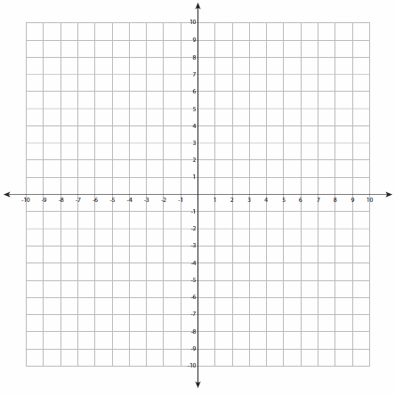
Coordinates: Graph:

