NAME: _______________________________
The Crucible
Act 3 Test
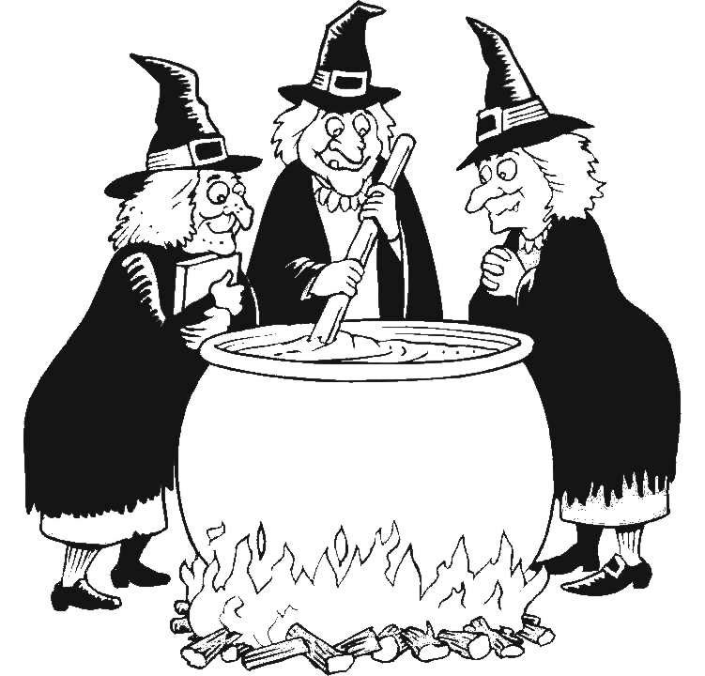

The Crucible – Act 1 Test

Part 1: Vocabulary (8 MARKS) - /10
Define each word:
Anteroom:
Prosecutor:
Remorseless:
Befouled:
Confounded:

Part 2: Character Identification (12 marks) /20
Identify the character being described in each of the following statements
I threaten a judge when he questions my honesty and authority in the court room.
My name is
I admit to having an affair with the young woman who used to be my maid.
My name is
I tell the first lie of my life to protect my husband.
My name is
I claim that I was lying in the courtroom but become intimidated by my friends and go back on my story.
My name is
I start to see the falsity of these court proceedings and when logic will not be heard I denounce the court proceedings.
My name is
I refuse to give the court the name of a person and am therefore arrested.
My name is
In my efforts to free my wife and the wives of my friends I accidentally get 91 people arrested for questioning.
My name is
I insist that the all of the names on petitions brought in by the husband of one of our prisoners be arrested for questioning.
My name is
I question the group of girls when accusations that they may be lying surface.
My name is
It comes out in the court that I witnessed girls dancing naked in the forest, but I quickly deny it and redirect the blame towards someone else.
My name is
Part 4: Passage Identification (50 marks) /70
You will select 7 of the quotes to write about. In each answer you must include:
- Who is the speaker?
- Who are they talking to and/ or about?
- What is the context of the quote? (What is going on in the play)
- What are some of the key words in the quote that make it important?
- What is the overall significance of the quote?
If you need more space you can write on the back of the paper.
***MAKE SURE YOU DO THE BONUS QUESTION ON THE LAST PAGE***

- “I will not give you no name, I mentioned my wife’s name once and I’ll burn in hell long enough for that. I stand mute.”
  - Who is the speaker?
  - Who are they talking to and/ or about?
  - What is the context of the quote? (What is going on in the play)
  - What are some of the key words in the quote that make it important?
  - What is the overall significance of the quote?

- “I have signed 72 death warrants; I am a minister of the Lord, and I dare not take a life without there be a proof so immaculate no slightest qualm of conscience may doubt it.”
  - Who is the speaker?
  - Who are they talking to and/ or about?
  - What is the context of the quote? (What is going on in the play)
  - What are some of the key words in the quote that make it important?
  - What is the overall significance of the quote?

- “Why not? There are no spirits attacking her, for none in this room is accused of witchcraft. So let her turn herself cold now, let her pretend she is attacked now, let her faint. Faint!”
  - Who is the speaker?
  - Who are they talking to and/ or about?
  - What is the context of the quote? (What is going on in the play)
  - What are some of the key words in the quote that make it important?
  - What is the overall significance of the quote?

- “I – I cannot tell how, but I did. I –I heard the other girls screaming, and you, Your Honor, you seem to believe them, and I – It were only sport in the beginning, sir, but then the whole world cried spirits, spirits, and I – I promise you, *****, I only thought I saw them but I did not.” Who is the speaker?
  - Who are they talking to and/ or about?
  - What is the context of the quote? (What is going on in the play)
  - What are some of the key words in the quote that make it important?
  - What is the overall significance of the quote?

- “Let you beware, *****. Think you to be so mighty that the power of Hell may not turn your wits? Beware of it!” Who is the speaker?
  - Who are they talking to and/ or about?
  - What is the context of the quote? (What is going on in the play)
  - What are some of the key words in the quote that make it important?
  - What is the overall significance of the quote?

- “I have known her sir, I have known her.”
  - Who is the speaker?
  - Who are they talking to and/ or about?
  - What is the context of the quote? (What is going on in the play)
  - What are some of the key words in the quote that make it important?
  - What is the overall significance of the quote?

- “Excellency, it is a natural lie to tell; I beg you, stop now before another is condemned! I may shut my conscience to it no more – private vengeance is working through this testimony!”
  - Who is the speaker?
  - Who are they talking to and/ or about?
  - What is the context of the quote? (What is going on in the play)
  - What are some of the key words in the quote that make it important?
  - What is the overall significance of the quote?

- “Oh, *****, this is a black art to change your shape. No, I cannot, I cannot stop my mouth; it’s God’s work I do.”
  - Who is the speaker?
  - Who are they talking to and/ or about?
  - What is the context of the quote? (What is going on in the play)
  - What are some of the key words in the quote that make it important?
  - What is the overall significance of the quote?

- “My name, he want my name. “I’ll murder you” he says, “if my wife hangs! We must go and overthrow the court,” he says!”
  - Who is the speaker?
  - Who are they talking to and/ or about?
  - What is the context of the quote? (What is going on in the play)
  - What are some of the key words in the quote that make it important?
  - What is the overall significance of the quote?

- “I say – I say – God is dead… a fire, a fire is burning! I hear the boot of Lucifer, I see his filthy face! And it is my face and yours, *****!”
  - Who is the speaker?
  - Who are they talking to and/ or about?
  - What is the context of the quote? (What is going on in the play)
  - What are some of the key words in the quote that make it important?
  - What is the overall significance of the quote?

BONUS QUESTION:
“I believe him! This girl has always struck me as false! She has –“
Hint: the speaker gets cut off by the girl he/she is talking about…
  - Who is the speaker?
  - Who are they talking to and/ or about?
  - What is the context of the quote? (What is going on in the play)
  - What are some of the key words in the quote that make it important?
  - What is the overall significance of the quote?
____________________________________________________________________________________________________________________________________________________________________________________________________________________________________________________________________________________________________________________________________________________________________________________________________________________________________________________________________________________________________________________________________________________________________________________________________________________________________________________________________________________________________________________________________________________________________________________________________________________________________________________________________________________________________________________________________________________________________________________________________________________________________________________________________________________________________________________________________________________________________________________________________________________________________________________________________________________________________________________________________________________________________________________________________________________________________________________________

